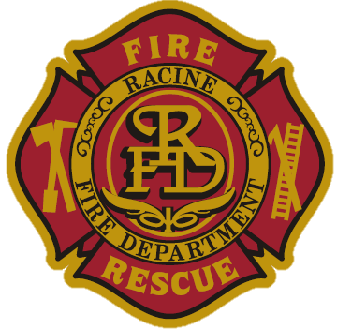
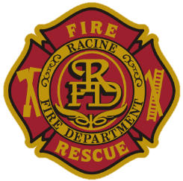
Racine Fire Department

Police & Fire Commission – NEW RECRUIT ORAL EVALUATION 2025

Candidate Name: _____________________________

- Why do you want to work at the Racine Fire Department?

- Aside from wanting to help people, what was your motivation to become a firefighter?

- Situational Question:
Describe a scenario where you had to communicate effectively with someone in a stressful situation. How did you ensure clear communication under pressure?

- Do you have any questions for the Police and Fire Commission?

